1. **White Box**
2. **Flowchart USER**

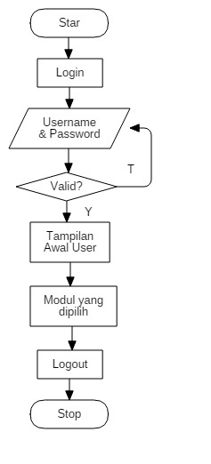

Control Flow Graph (CFG) User :

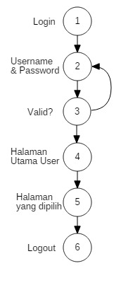

* Cyclomatic Complexity

V(G) = E – N +2

= 6 – 6 – 2

= 2

* Basic Path :
* Path 1 : 1 – 2 – 3 – 4 – 5 – 6
* Path 2 : 1 – 2 – 3 – 2

1. **Flowchart Admin**

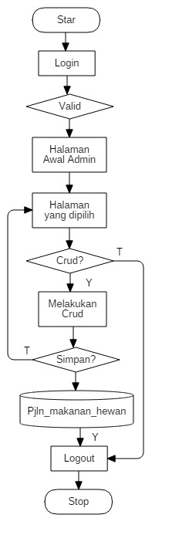

Control Flow Graph (CFG) admin :

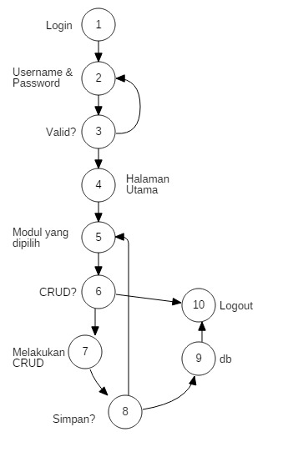

* Cyclomatic Complexity

V(G) = E – N +2

= 12 – 10 + 2

= 4

* Basic Path :
* Path 1 : 1 – 2 – 3 – 4 – 5 – 6 – 7 – 8 – 9 – 10
* Path 2 : 1 – 2 – 3 – 4 – 5 – 6 – 10
* Path 3 : 1 – 2 – 3 – 4 – 5 – 6 – 7 – 8 – 5 – 6 – 10
* Path 4 : 1 – 2 – 3 - 2

1. **Black Box**
2. **Equivalent**

Id : 11

|  |  |  |
| --- | --- | --- |
| **Invalid** | **Valid** | **Invalid** |
| ….-100 - 0 | 1 - 11 | 12 – 100…. |

Judul : 30

|  |  |  |
| --- | --- | --- |
| **Invalid** | **Valid** | **Invalid** |
| ….-100 - 0 | 1 – 30 | 31 – 100…. |

Konten : 80

|  |  |  |
| --- | --- | --- |
| **Invalid** | **Valid** | **Invalid** |
| ….-100 - 0 | 1 - 80 | 81 – 100…. |

Gambar : 3

|  |  |  |
| --- | --- | --- |
| **Invalid** | **Valid** | **Invalid** |
| ….-100 - 0 | 1 – 3 | 4 – 100…. |

No hp : 12

|  |  |  |
| --- | --- | --- |
| **Invalid** | **Valid** | **Invalid** |
| ….-100 - 0 | 1 – 12 | 13 – 100…. |

Tanggal Masuk 30

|  |  |  |
| --- | --- | --- |
| **Invalid** | **Valid** | **Invalid** |
| ….-100 - 0 | 1 – 30 | 31 – 100…. |

1. **Tabel Kebenaran**

* Validasi Login

|  |  |  |  |  |
| --- | --- | --- | --- | --- |
| Username | F | F | T | T |
| Password | F | T | F | T |
| Hasil | Error | Error | Error | Berhasil login |

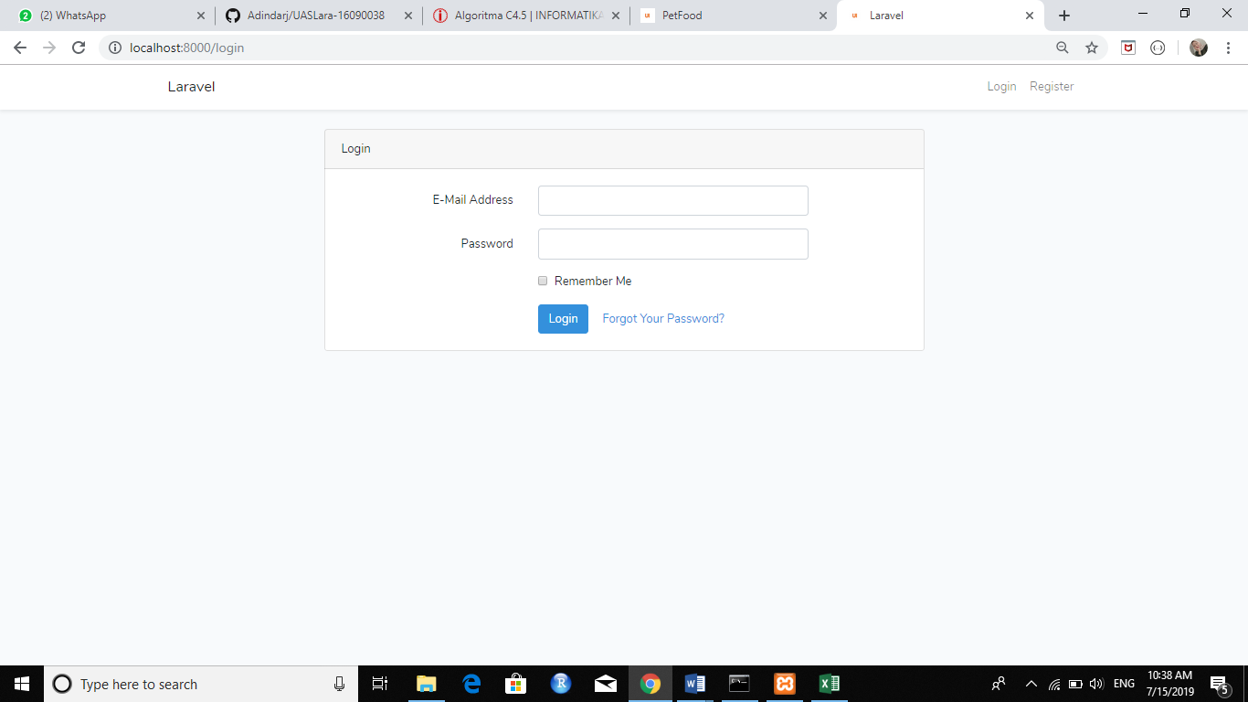

* **Validasi Tambah Produk**

|  |  |  |  |  |
| --- | --- | --- | --- | --- |
| Nama Produk | T | T | T | T |
| Harga | F | T | T | T |
| Deskripsi | F | F | T | T |
| Gambar | F | F | F | T |
| Hasil | Error | Error | Error | Berhasil |

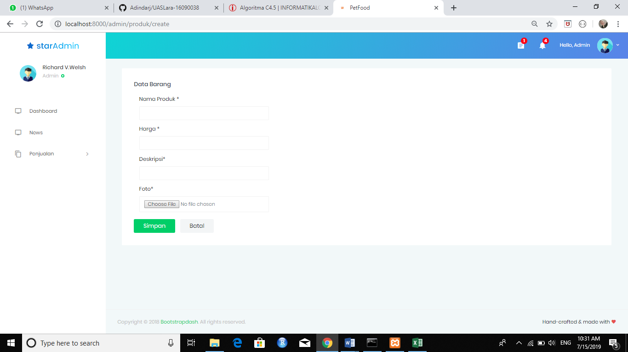

* **Validasi Edit Produk**

|  |  |  |  |  |
| --- | --- | --- | --- | --- |
| Nama Produk | T | T | T | T |
| Harga | F | T | T | T |
| Deskripsi | F | F | T | T |
| Gambar | F | F | F | T |
| Hasil | Error | Error | Berhasil | Berhasil |

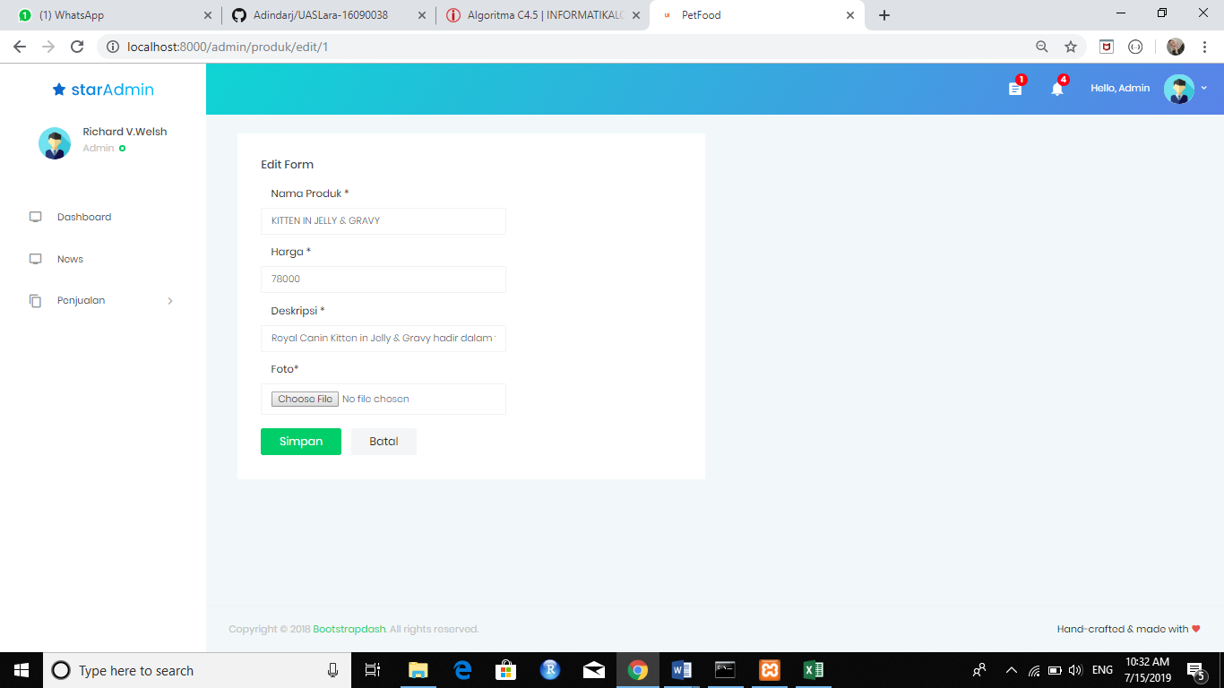

* Tampilan Formulir Pembelian

|  |  |  |  |  |
| --- | --- | --- | --- | --- |
| Nama Produk | T | T | T | T |
| Email | F | T | T | T |
| Produk | F | T | T | T |
| Alamat | F | F | F | T |
| No Hp | F | F | F | T |
| Hasil | Error | Error | Error | Berhasil |

